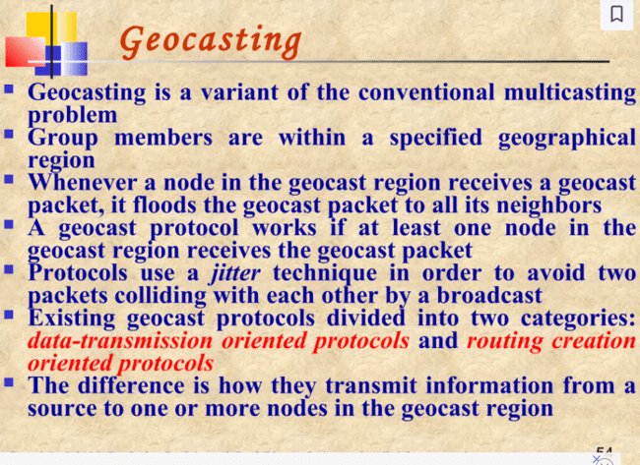

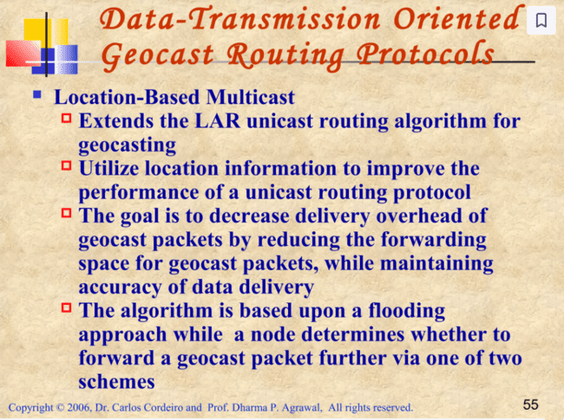

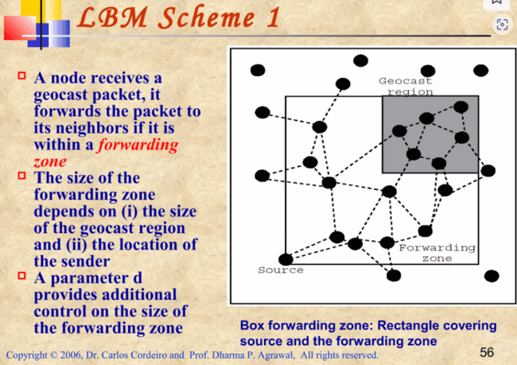

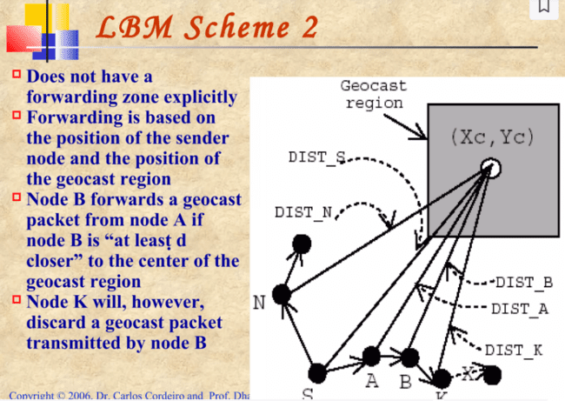

**Routing creation Oriented protocol**

**GeoTORA**

1. GeoTORA aims to reduce the overhead of transmitting geocast packets via flooding techniques while maintaining high accuracy.
2. **Usage of TORA**: GeoTORA utilizes the unicast routing protocol TORA (Temporally-Ordered Routing Algorithm) to transmit geocast packets to a geocast region.
3. **TORA Characteristics**:
   * TORA is a distributed routing protocol.
   * It is based on a "link reversal" algorithm.
   * TORA provides multiple routes to a destination.
   * TORA maintains a destination-oriented directed acyclic graph (DAG) even during dynamic link failures, ensuring each node can reach the destination.
4. **GeoTORA Mechanism**:
   * The source node performs an anycast to any geocast group member (any node in the geocast region) via TORA.
   * Once a node in the geocast region receives the packet, it floods the packet, but the flooding is restricted to the geocast region.
5. **Accuracy**:
   * GeoTORA has high accuracy, though not as high as pure flooding or Location-Based Multicast (LBM).
   * The accuracy decreases if only one node in the geocast region receives the packet and that node is partitioned from others in the region.

**Mesh-based Geocast Routing (MGR)**

The Mesh-based Geocast Routing (MGR) protocol is designed for geocasting in an ad hoc environment, aiming to provide redundant paths between the source and group members.

**Redundant Paths**:

* MGR creates redundant paths from the source to the geocast region because the group members in a geocast region are in close proximity.
* This proximity makes it less costly to establish redundant paths compared to multicast groups where nodes might be spread out.

**Flooding and Control Packets**:

* Instead of flooding geocast packets, MGR uses control packets to create redundant routes.
* The protocol begins by flooding **JOIN-DEMAND** packets within a defined forwarding zone.

**JOIN-DEMAND and JOIN-TABLE Packets**:

* A **JOIN-DEMAND** packet is forwarded across the network until it reaches a node within the geocast region.
* Upon reaching a geocast region node, the node unicasts a **JOIN-TABLE** packet back to the source by following the reverse path of the JOIN-DEMAND packet.

**Mesh Formation**:

* Nodes on the edge of the geocast region, after receiving the JOIN-TABLE packet, become part of the mesh.
* Once the source receives the first JOIN-TABLE packet, it can begin sending data packets to nodes within the geocast region.

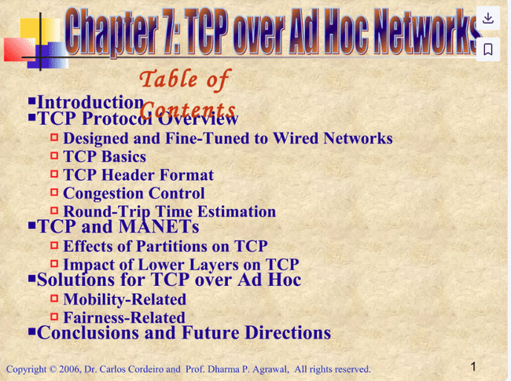

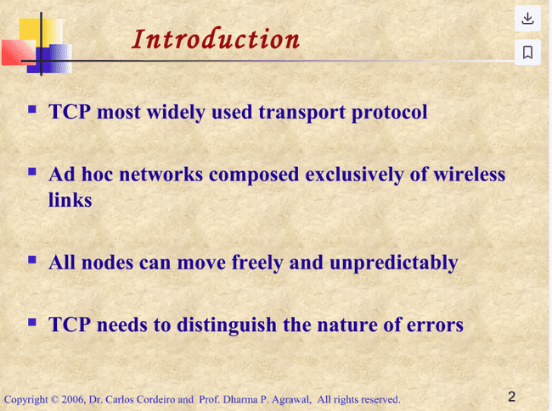

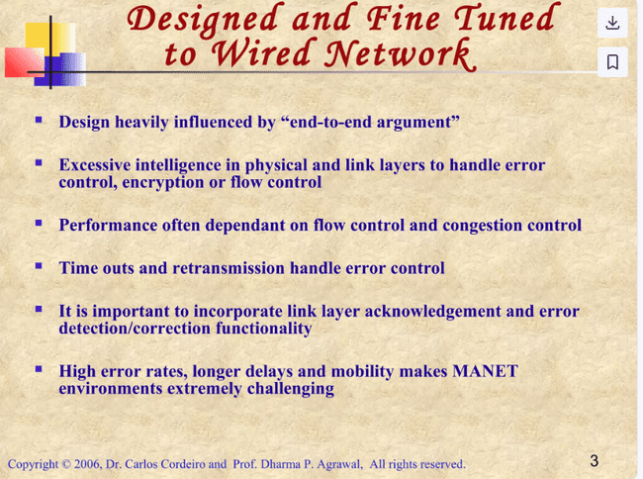

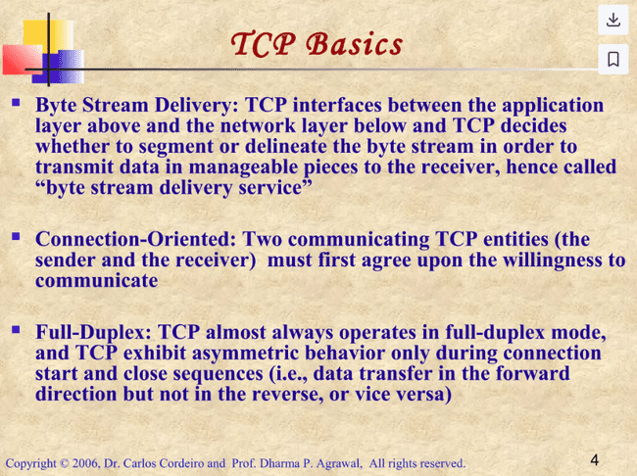

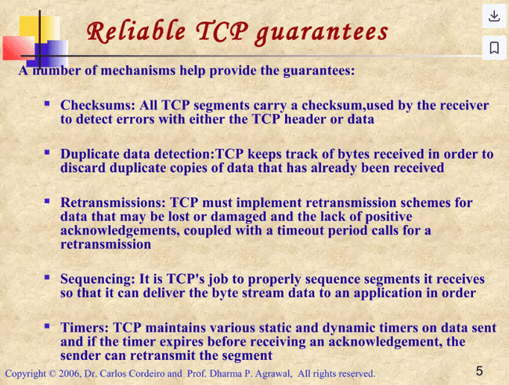

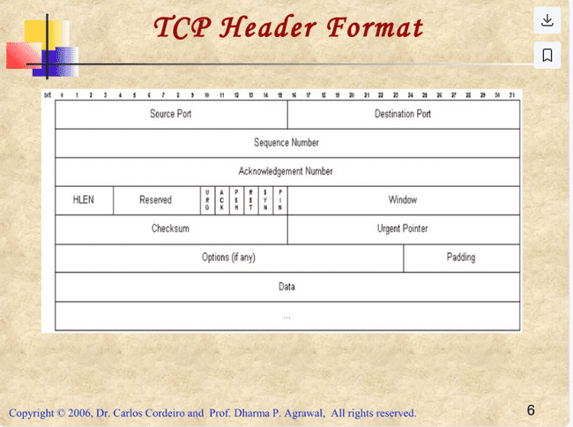

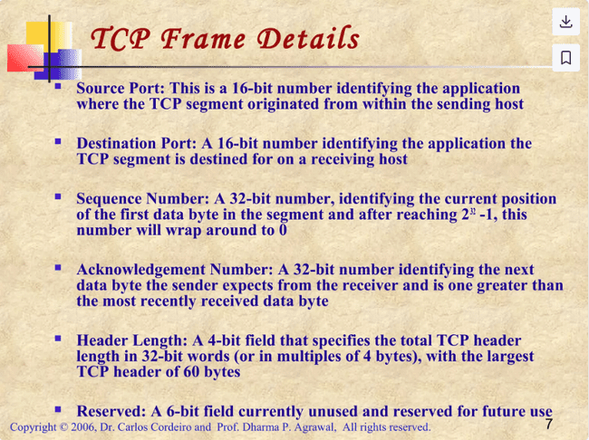

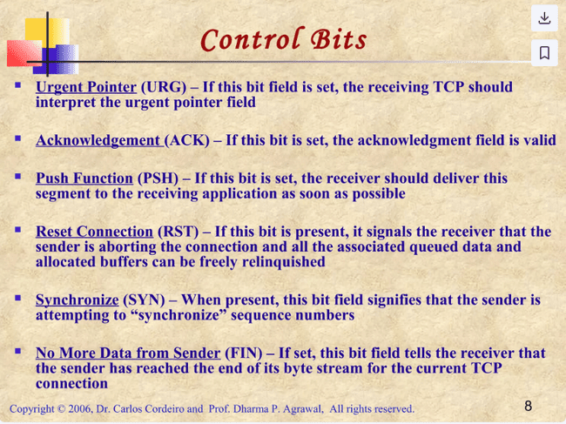

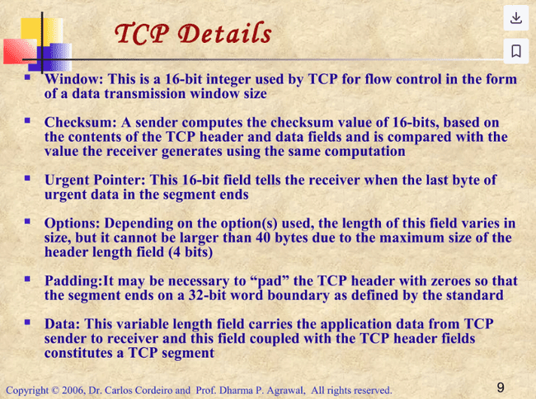

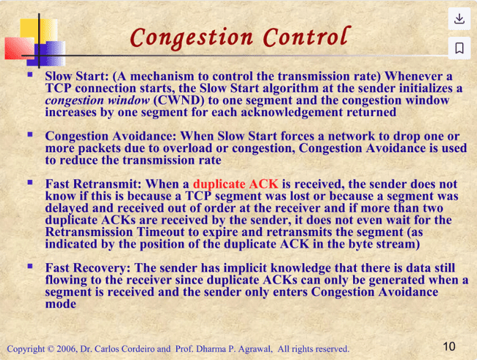

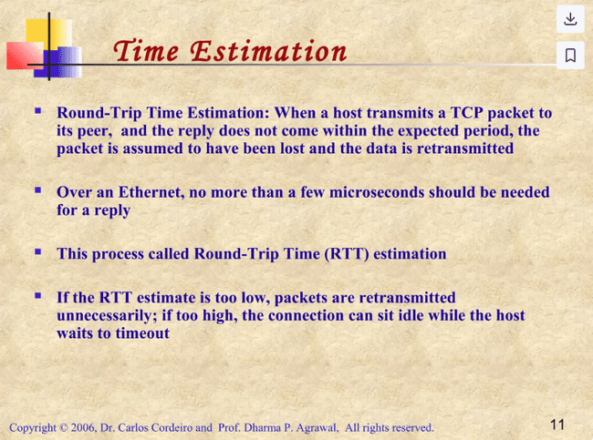

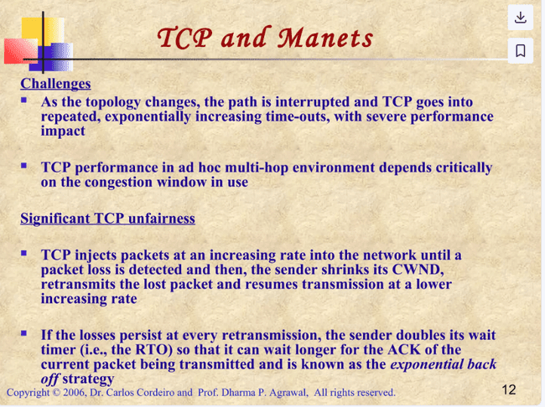

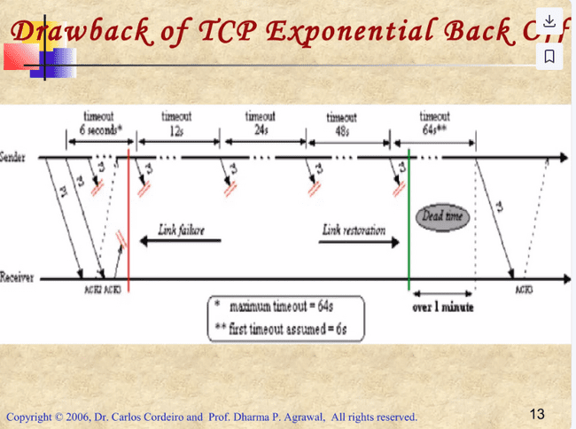

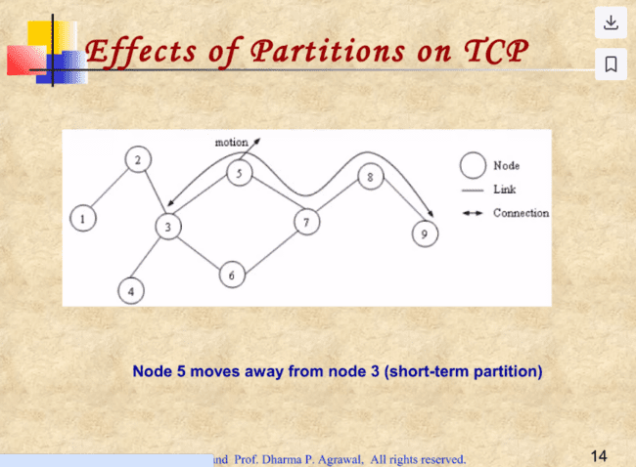

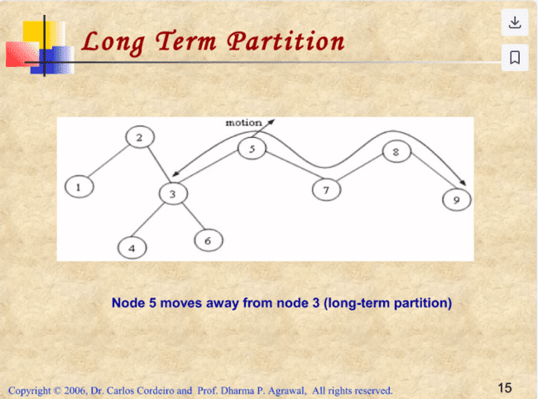

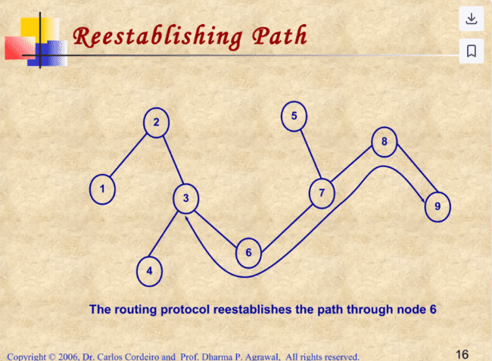

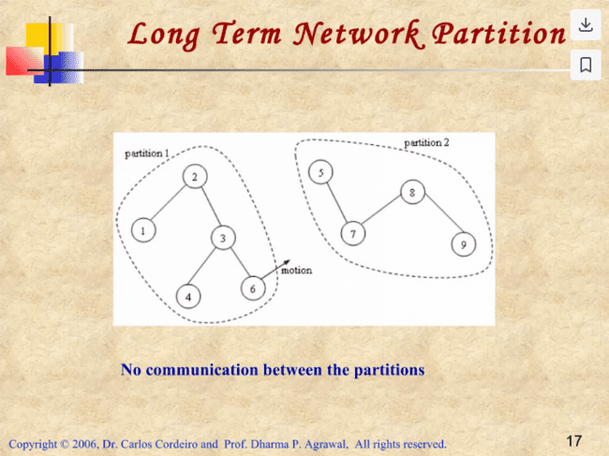

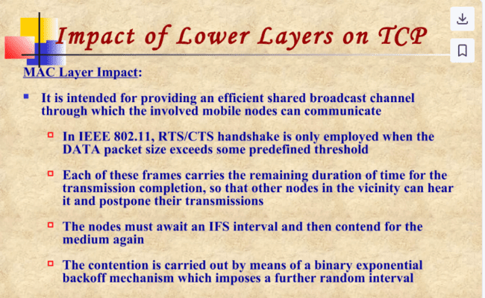

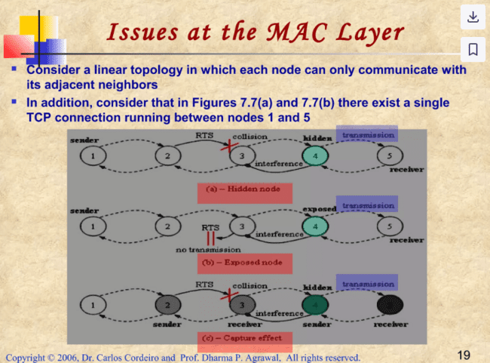

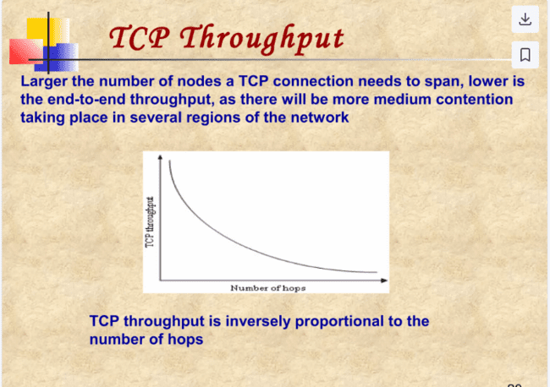

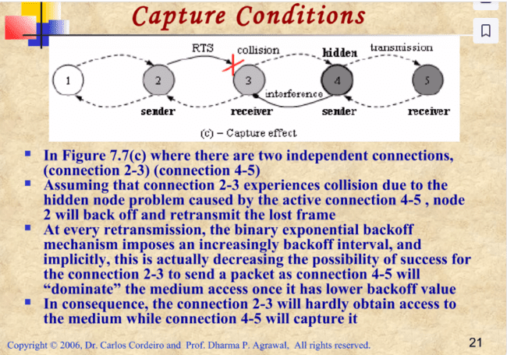

**NETWORK LAYER IMPACT**

**DSR Protocol Overview:**

* **On-Demand Operation**: DSR works on an on-demand basis, meaning routes are discovered only when needed. When a node wants to send data to a destination, it broadcasts a route request (RREQ).
* **Route Reply (RREP)**: Once the destination or another node with route knowledge receives the RREQ, it sends back a route reply (RREP) to the sender, specifying the route to the destination.
* **Route Caching**: Each node in the network stores routes it has learned or overheard in its route cache. This eliminates the need for keeping constant, up-to-date routing tables, reducing the need for periodic route advertisements, which could otherwise cause network overhead.

**Problem with Stale Routes:**

* **Stale Routes**: In highly dynamic environments where nodes are frequently moving (high mobility) or the network conditions change (e.g., signal interference), routes can become invalid quickly.
  + For instance, a route could become outdated by the time the RREP is returned, either because a node in the route has moved or a link is broken.
  + Other nodes might overhear this outdated RREP and update their route caches with invalid information, causing further issues.
* **Impact on TCP**: When invalid routes are used, TCP (Transmission Control Protocol) experiences delays in sending data. If this delay isn't handled properly, TCP can enter a "backoff" state, which significantly degrades its performance.

**Solutions:**

* **Avoiding Route Cache Replies**: One approach to mitigate stale route issues is to prevent nodes from replying using their cached routes. While this can improve route accuracy, it increases network overhead because every new route discovery requires broadcasting a new RREQ across the network.
* **Trade-off**: Although this extra overhead increases network traffic, it is balanced by the improvement in route accuracy, particularly in networks with high mobility. As a result, TCP performance can be enhanced because the likelihood of using stale routes is reduced.

**TORA Protocol**

* **Hybrid Nature**: TORA is primarily an on-demand protocol, but it also has proactive features. It is designed for dynamic environments, quickly establishing routes while minimizing the control messages (overhead) to a small set of nodes around the area where a topological change (like a node movement or failure) has occurred.
* **Multiple Routes**: TORA maintains multiple routes between peers, meaning that a single topological change doesn't always trigger a route discovery process unless all routes to a destination are lost. This is achieved using **Directed Acyclic Graphs (DAGs)**, where every node has a path to the destination, allowing for several alternative paths.
* **Efficient Route Maintenance**: A route discovery process occurs only when no more routes are available. When invalid routes are detected (due to changes like network partition), affected nodes send a "clear packet" to remove the stale route from their neighbors, avoiding unnecessary network-wide reactions.

**Problems with Stale Routes:**

* Like the **Dynamic Source Routing (DSR)** protocol, TORA can suffer from stale route problems. If TCP attempts to send data through a route that has become invalid, delays or errors can occur.
* However, because TORA only reacts when all routes are unavailable, stale routes are less problematic compared to DSR. The multiple paths in TORA make route discovery less frequent, which reduces the potential negative effects on TCP.

**Problem with Multiple Paths and TCP:**

* **Out-of-Order Packets**: While TORA's multiple path approach provides redundancy and reliability, it introduces the issue of out-of-order packet delivery. Since TORA doesn’t prioritize shorter paths, packets can arrive at the destination in the wrong sequence, which is problematic for TCP.
  + For example, an older packet could be sent along a longer path, while a newer packet might be sent through a shorter path, arriving first at the destination. This forces TCP to retransmit packets due to the perceived loss of the earlier packet, degrading overall performance.
* **Potential Solution**: To address this, a **self-adaptive mechanism** could be introduced, ensuring that shorter paths are preferred or at least managing path selection in a way that minimizes out-of-sequence packet arrivals.

**Impact on TCP and Routing Protocol Design:**

* **Cross-Layer Design**: The analysis of both DSR and TORA shows that the design of routing protocols should carefully consider their impact on the upper layers, particularly the widely used TCP protocol. Cooperation between the network layer (routing) and transport layer (TCP) through cross-layer design could provide solutions to these challenges, improving the overall network performance.

